Capstone Project Detailed Report

Prepared by:- ABHAY SHARMA
Date: - 16-11-2025
This is a Detailed Report for Power Bi Dashboard which have all the tasks and their visuals with detailed Explanation

Table of Contents
1. Top Categories by Total Price
2. Delayed Orders Analysis
3. Monthly Comparison of Delayed and On-Time Orders
4. Payment Method Analysis
5. Product Rating Analysis
6. State-wise Sales Analysis
7. Seasonal Sales Patterns
8. Revenue Analysis
1.Top Categories by Total Price
Question 1:- Identify And Visually Represent The Top 10 Product Categories By Total Sales?
- Visualization:-
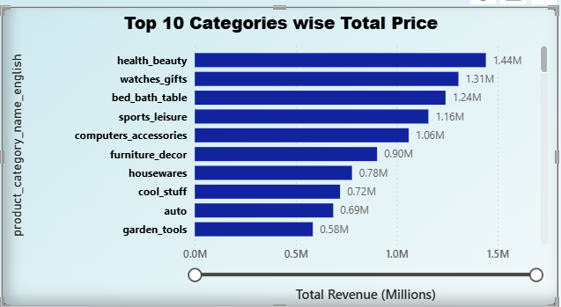

Explanation:- This analysis identifies the top 10 product categories generating the highest total sales. The total price for each category was calculated by summing the product revenue associated with all orders in that category. The purpose of this analysis is to understand which product categories contribute most to overall business profitability.
Key Insights:
- Health & Beauty, Watches & Gifts, and Bed, Bath & Table are the top-performing categories.
- Together, these top categories account for a significant share of total revenue.
- Categories like Garden Tools and Auto appear in the lower range of the top 10, indicating either fewer orders or lower-priced products.
- The business can focus marketing and inventory management efforts on the top categories to maximize revenue

2. Delayed Orders Analysis
Question 2:- Determine The Number Of Delayed Orders In Each Category. An Order Is Considered Delayed If The Actual Delivery Date Is Later Than The Estimated Delivery Date?
- Visualization:-
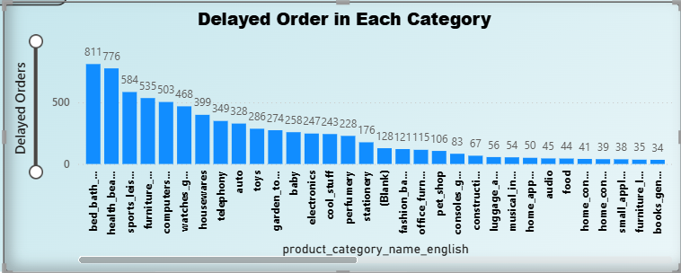

Explanation:- This analysis determines how many orders were delivered later than the estimated delivery date. An order is considered delayed if the actual delivery date > estimated delivery date. The delayed orders were grouped by product category to understand which categories experience the most delays.
Key Insights:
- Categories like Bed, Bath & Table, Health & Beauty, and Sports & Leisure show the highest number of delayed orders.
- This could be due to bulky items, fragile products, or supply-chain challenges.
- Lower delayed counts in categories like Cool Stuff and Garden Tools suggest more efficient logistics or smaller product size.
- These insights can help improve delivery planning, vendor performance, and customer satisfaction.

3. Monthly Comparison of Delayed and On-Time Orders
Question 3:- Create A Dynamic Visual That Compares The Number Of Delayed Orders To The Number Of Orders Received Earlier For Each Month. Utilize The Drillthrough Cross-Report Feature To Provide A Detailed Analysis Of Late And On-Time Deliveries?

- Visualization:-
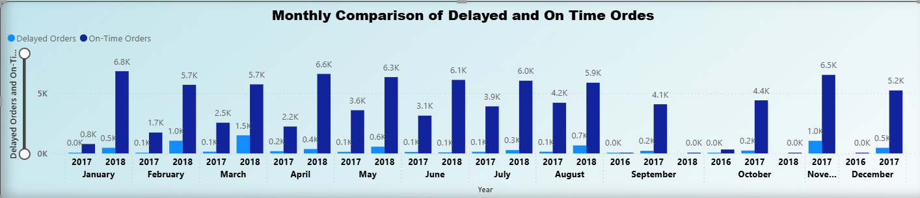

Explanation:- This comparison examines monthly trends of delayed and on-time deliveries. Delayed orders are those where the delivered date is later than the estimated date; all others are considered on-time. This analysis helps identify performance patterns over time.
Key Insights:
- Delayed orders are significantly higher than on-time orders for most months.
- Peaks in delayed orders occur mainly in mid-2017 and early 2018.
- On-time orders follow a similar trend but remain much lower than delayed orders.
- The visualization reveals operational bottlenecks, seasonal spikes, and months that require attention for improving logistics.
4. Payment Method Analysis
Question 4:- Analyze The Most Frequently Used Payment Methods By Customers Using A Visually Appealing Representation, Such As A Pie Chart Or Other Suitable Visuals?
- Visualization:-
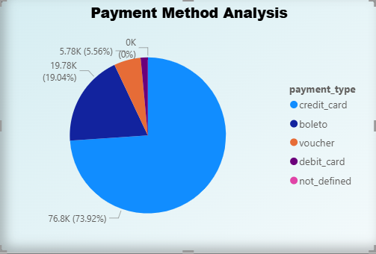

Explanation:- This task analyzes the most frequently used payment methods by customers. The payment types include credit card, boleto, voucher, and debit card. Each payment record represents a payment attempt or installment.
Key Insights:
- Credit card is the overwhelmingly dominant payment method, accounting for nearly 75–80% of all payments.
- The second-most-used payment method is boleto, a traditional Brazilian payment option.
- Voucher and debit card are rarely used, showing limited customer preference.
- The company should ensure a secure and smooth credit card payment process since it supports the majority of transactions.
5. Product Rating Analysis
Question 5:- Determine The Top 10 Highest-Rated Products And The Bottom 10 Lowest-Rated Products Using A Bar Or Column Chart?

- Visualization:-
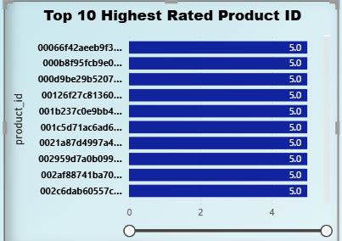
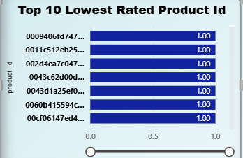
Explanation:- This analysis identifies the top 10 highest-rated and bottom 10 lowest-rated products based on customer reviews. The review scores reflect customer satisfaction and product quality.
Key Insights:
- Several products have consistently high ratings (4.5 to 5 stars), indicating excellent customer satisfaction.
- The lowest-rated products (1 to 2 stars) indicate quality issues, unmet expectations, or misleading product descriptions.
- The business should further investigate the lowest-rated products to improve customer trust and reduce return rates.
- Highly rated products can be promoted more aggressively, as they contribute to positive customer experiences.
6. State-wise Sales Analysis
Question 6:- Identify And Visually Represent States With High And Low Sales, Providing A Clear Understanding Of Regional Sales Performance?

- Visualization:-

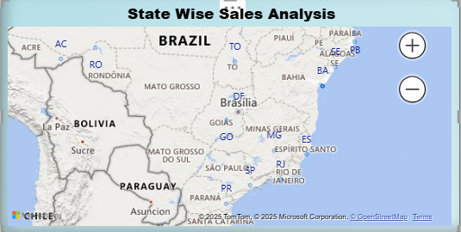

Explanation:- This task identifies customer states contributing most to total sales. The analysis uses customer location data to determine revenue distribution across states.
Key Insights:
- São Paulo (SP) is the highest revenue-generating state by a very large margin.
- Other strong-performing states include Rio de Janeiro (RJ), Minas Gerais (MG), Rio Grande do Sul (RS), and Paraná (PR).
- Many smaller states contribute minimally to total sales.
- The company can prioritize inventory placement, marketing, and faster delivery strategies in top-performing states.
7. Seasonal Sales Patterns
Question 7:- Investigate And Visualize Any Seasonal Patterns (Quarterly) Or Trends In Sales Data Over The Course Of The Year?

- Visualization:-

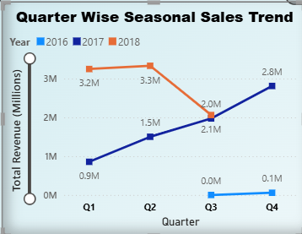

Explanation:- This analysis studies quarterly seasonal trends in sales. It tracks how customer purchasing behavior varies across Q1, Q2, Q3, and Q4 over different years.
Key Insights:
- Sales show an upward trend from 2016 to 2018.
- Peaks are observed around Q1 and Q3, suggesting strong seasonal demand during these quarters.
- Lower sales in Q4 could be due to reduced promotions or holiday season logistics.
- Understanding seasonal patterns helps in demand forecasting, stock planning, and budget allocation.

8. Revenue Analysis
Question 8:- Determine The Total Revenue Generated By ShopNest Store And Analyze How It Changes Over Time (Yearly).
- Represent This Information Through Suitable Visuals To Highlight Trends And Patterns?

- Visualization:-

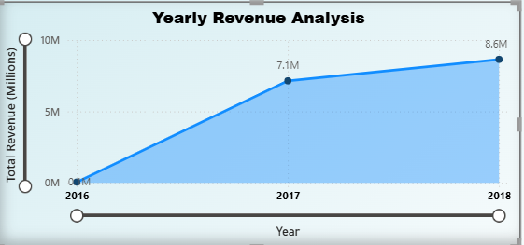

Explanation:- This task calculates the total revenue generated each year by summing the product prices from order items. It helps understand overall revenue growth and business performance over time.
Key Insights:
- Revenue has shown a strong growth trend from 2016 to 2018.
- 2018 records the highest revenue, indicating business expansion and improved market penetration.
- The consistent upward revenue trend reaffirms that the company is moving in the right direction.
- These insights can guide investment, resource planning, and strategic decisions.

Thank you for reviewing my Power BI Dashboard Project.

